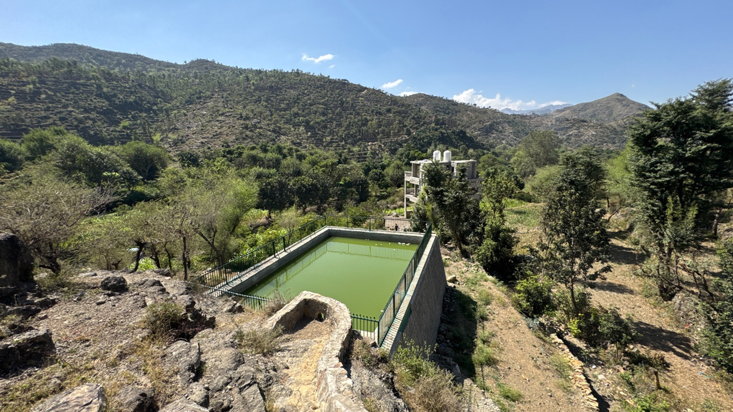
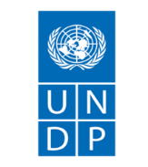

SEMI-ANNUAL PROGRESS REPORT
July 1– 31 December 2025

YEMEN FOOD SECURITY RESPONSE AND RESILIENCE PROJECT (YFSRRP)

Tracy Vienings, International Project Manager tracy.vienings@undp.org
Lina Y. Al-Safi, National Coordinator Lina.Al-Safi@undp.org

February 15, 2026

ABBREVIATIONS AND ACRONYMS
AF | Additional Financing
ACAPS  CfW | Assessment Capacities Project  Cash for Work
ESAP  ESCP  ESF  ESMF  ESMP  ESPECRP  ESS  ESRAAC  FAO  GAFSP  GBV (Plan)  GM  IDA  IPs | Environmental and Social Action Plan  Environmental and Social Commitment Plan  Environmental and Social Framework  Environmental and Social Management Framework  Environmental and Social Management Plan  Emergency Social Protection Enhancement and COVID-19 Response Project  Environmental and Social Standards  Environmental and Social Risk Assessment and Clauses  Food and Agriculture Organization  Global Agriculture Food Security Program  Gender-Based Violence (Plan)  Grievance Mechanism  International Development Association  Implementing Partners
IRG  ISM  OHS | Internationally Recognized Government of Yemen  Implementation Support Mission  Occupational Health and Safety
KPI | Key Performance Indicators
LMP  MoAIF  MoFA  PAD  PSEA | Labor Management Procedure  Ministry for Agriculture, Irrigation and Fisheries  Ministry of Foreign Affairs  Project Appraisal Document  Protection from Sexual Exploitation and Abuse
PTW | Permit to Work
PWP  PWD  RRF  RVM  SCMCHA  SDR  SEA  SEP  SFD  SMP  ToR  TPM | Public Works Project  Persons with Disability  Results and Resources Framework  Remote Verification Mechanism  Supreme Council for the Management and Coordination of Humanitarian Affairs  Special Drawing Rights  Sexual Exploitation and Abuse  Stakeholder Engagement Plan  Social Fund for Development  Security Management Plan  Terms of Reference  Third-Party Monitoring
TTL | Task Team Leader
WB | World Bank
YFSRRP  YKB | Yemen Food Security Resilience Response Project  Yemen Kuwait Bank

Contents
1. OPERATING ENVIRONMENT SUMMARY 5
1.1 Security Issues & Access 5
1.2 Interaction with authorities 8
2. SUMMARY OF MAIN ISSUES AND KEY ACHIEVEMENTS 8
Output 1: Improving agricultural production infrastructure and building climate resilience (SFD) 9
Output 2: Small-scale agricultural production community infrastructure rehabilitated (PWP) 12
3. ENHANCE EFFECTIVE GEOGRAPHIC TARGETING AND IMPROVED LINKAGES BETWEEN PROJECT COMPONENTS 15
4. COMPONENT 5: PROJECT MANAGEMENT AND KNOWLEDGE MANAGEMENT 15
5. OPERATIONS 15
5.1 Procurement plan: 15
5.2 Budget Status 17
6. IMPLEMENTATION OF ENVIRONMENTAL AND SOCIAL FRAMEWORK 18
6.1 Environmental and Social Framework (ESF) Status 18
6.2 Environmental and Social Plans and Risk Assessments 18
6.3 Conflict Sensitivity 18
6.4 Environmental and Social Safeguard Monitoring Indicators 19
6.5 Incidents and Accidents 19
6.6 Capacity Building Trainings and Awareness 20
6.7 Field Visits 20
6.8 Gender Mainstreaming 21
6.9 Grievance Mechanism (GM) 22
6.10 Stakeholder Engagement & Consultations 23
7. MONITORING AND EVALUATION 23
7.1 UNDP Field Visits 23
7.2 Third-Party Monitoring (TPM) 25
7.3 Financial Spot Checks 26
7.4 Rapid Impact Assessment 26
7.5 MIS Development for Project Management and Geo-Bundling Initiatives 26
8. OTHER ISSUES REQUIRING ATTENTION 27
8.1 Restructuring of activities 27
8.2 Results reporting 27
8.3 Reallocations between components and/or expenditure categories: 27
8.4 Possible funding gaps: N/A 27
9. STATEMENTS ON ALLEGATIONS 27
10. PROGRESS TOWARDS PROJECT RESULTS FRAMEWORK 28
11. COMMUNICATION 29

ANNEXES:
Annex 1: Social Safeguard and Environmental Report

OPERATING ENVIRONMENT SUMMARY

Security Issues & Access
Pause on disbursement and implementation in Houthi-Controlled Areas:
Security conditions in Houthi areas worsened during September and October 2025, marked by raids on UN premises and detention of staff. In response, the World Bank, in consultation with UNDP, suspended project implementation and disbursements in Houthi-controlled areas effective 21 October 2025. This came after a decision from UNDP to pause disbursement to SFD on 17 August 2025 across the country. This is in relation to internal institutional management issues that struck the governance and directly impacting FSRRP implementation.
UNDP promptly operationalized the pause in accordance with agreed arrangements and progressed verification and settlement of eligible pre-pause commitments using conservative payment modalities, including direct payment and reimbursement. Based on jointly agreed eligibility criteria, UNDP submitted selected high-risk and time-critical activities for WB approval on a case-by-case basis, to ensure safe completion where prolonged suspension would pose contractual, environmental, social, or reputational risks.
The WB pause of the 21st affected SFD across the country and is still in effect as of date of reporting. Its worth noting that high-level mediation is taking place resulting in a proposed 12 points internal agreement to bring the issue to a manageable end. PWP was affected by the pause in the Northern areas while is fully operation in the South.
SFD Leadership Dispute: A leadership dispute emerged within SFD in mid-August 2025 following the appointment of a new Managing Director by the Internationally Recognized Government and the suspension of the incumbent’s signatory authority. The dispute generated institutional uncertainty, disrupted financial processing across SFD branches, and adversely affected project delivery, including the suspension
Activities implemented through SFD and SMEPS remain paused pending resolution of governance issues. Throughout the pause period, UNDP maintained third-party monitoring to ensure continued oversight and accountability.
UNDP commissioned specialized legal advisory services, in agreement with the WB, to assess and mitigate risks related to the FTO designation and associated sanctions; the assignment is expected to conclude by end-February 2026.
Detention of UN Staff and Raids on UN Premises: Since early September 2025, the Houthis in Sana’a have detained national UN staff and conducted raids on UN premises, affecting multiple UN agencies, including UNDP. These developments significantly constrained operations in northern governorates by limiting staff movement, disrupting field monitoring, and suspending engagement with local authorities. The UN Country Team, under the leadership of the Resident and Humanitarian Coordinator and in coordination with Headquarters, continues high-level advocacy for the release of detained personnel. UNDP implemented enhanced security measures, limited field presence, and activated remote management and contingency protocols to safeguard staff safety and maintain critical operations, while sustaining essential service delivery in line with UN security and human rights principles.
Major Security and Political Developments – Aden: During the reporting period, the political and security situation in Aden experienced heightened volatility following an attempted expansion of influence by the Southern Transitional Council toward eastern governorates, which did not materialize. Swift political and security intervention by Saudi Arabia, including reinforcement of support to the Presidential Leadership Council, contributed to de-escalation and stabilization in Aden, preventing broader disruption. As a result, project implementation in southern areas was not materially affected and activities continued as planned. Nevertheless, the overall environment remains fragile, with ongoing political uncertainty posing potential risks to operational continuity. UNDP, in coordination with the WB, continues to monitor developments closely and apply enhanced risk management and contingency planning measures.

Close engagement with IPs and other stakeholders, with regular follow up and engagement to monitor the situation and develop long-term solutions to these challenges, is ongoing. YFSRRP provides regular cash position updates to the WB.
Official Movement and Access:
Yemeni national staff are allowed to fly out of Sana’a on UN-operated flights after obtaining a travel permit from concerned authorities. More restrictions are imposed on female national staff’s travel both domestically and out of the country. Female national staff are required to travel with a male escort (first degree relative or husband) or obtain official, endorsed written consent from a male relative for the travel, which in most cases is not a guarantee of travel facilitation by the security travel authority at Sana’a airport or check points in case of road travel.
The situation worsened with the most recent detentions of national UN personnel some of which were accused of treason
No major access or security challenges were reported in any of the target locations under component 1 by the IPs or the UNDP project team. No security incidents or access constraints were reported by the IPs during the reporting period.
Impact of WB Suspension on Northern Implementation and Disbursement
During the reporting period, the World Bank’s pause on activities in the North resulted in major disruption to planned and on-going interventions. This has adversely affected the implementation timeline and anticipated completion date of Component 1 implemented by UNDP. Ideally project implementation was planned to be completed by end of December 2025, but is now considered until end of 2026 as a result of the delays caused by the suspension.
Its worth noting that the pause will have additional financial implications given the fact that halted work and clearances have penalty charges that are contractually binding in addition to other operational costs.
The pause also slowed overall progress, given the large number of subprojects in the North, and increased social, environmental, and financial risks for both IPs and communities. These risks were classified, and the World Bank recently approved one of the lists provided for the SFD on a case-by-case basis.

It is of prime importance that more clarity is provided on the way forward and the scenarios the WB management is considered be that resumption of activities in the North or reallocation to the South or any other scenarios.
FSRRP continues to operate in a volatile environment marked by political instability, security incidents, banking disruptions, and governance shocks. Risks escalated late 2025 due to FTO re-designation, detention of UN staff, partner leadership disputes, and disbursement pauses. Despite this, resilience was demonstrated through adaptive delivery, risk mitigation, and strong coordination with WB and partners. Sustained flexibility and donor engagement remain critical to protect gains and restore momentum.

Interaction with authorities
UNDP ensures the involvement of all concerned stakeholders including authorities in the process of the identification and endorsement of the sub-projects, and the endorsement of the selected community committee members. In addition, UNDP is also working closely with local authorities to develop local plans and ensure that the interventions are responding to the needs of the target locations.
Both IPs were enlisted to be administratively under a Government Ministry/Entity, namely SFD under the Ministry of Social Affairs and Labor and PWP under the Ministry of Local Administration.
In response, SFD has communicated with its partners and the new government, receiving official assurances that SFD's independence will be respected in accordance with its formulation by presidential decree. PWP has also discussed arrangements with the new government to maintain its independence.
Project partners continue to coordinate with concerned authorities - both the Houthis and the Internationally Recognized Government (IRG). SFD has established a special liaison committee responsible for working with relevant authorities, as well as maintaining direct communication with local authorities and agricultural offices in all governorates through SFD branches. The committee's primary role is to establish effective channels of communication with the relevant authorities, promptly addressing any issues that may arise. In such cases, the local authorities and agricultural offices intervene to resolve these matters and facilitate the necessary procedures related to projects and SFD interventions across all governorates.
PWP continues to maintain constant cooperation and coordination with concerned authorities and stakeholders to ensure smoother and more effective implementation of interventions.

SUMMARY OF MAIN ISSUES AND KEY ACHIEVEMENTS
By the end of the reporting period, interventions under component 1 resulted in the generation of 42,964 temporary employment opportunities, out of which 3,999 were for female beneficiaries, representing 81 percent of the revised project end target of 52,900. This was met through generating 1,326,918 workdays, out of which 130,441 were for female beneficiaries, representing 86 percent of the revised project end target of 1,547,400.
Completed agricultural production infrastructure sub-projects have resulted in community benefits that included 201.8 kilometers of paved rural roads; 200,814 cubic meters of constructed and improved rainwater harvesting tanks; 8,573 hectares of improved and protected lands; 110,773 meters of constructed and improved irrigation canals; and 13,177 hectares of lands irrigated.
As a result of the above interventions, 17,249 farmers have improved access to agricultural land (4,026 female farmers), representing 128 percent of the total revised target of 13,500. In addition, 22,341 farmers have improved access to water resources to cultivate their lands (5,277 female farmers), representing 87 percent of the total target of 25,700.
During the reporting period an interim WB support mission was held from 16 to 27 November 2025. The mission discussed several key issues, such as the effective geographic targeting and improved linkages between Component 1 and Component 2, with a focus on enhancing smallholder farm households’ access to water resources in addition to other thematic UN partner agency specific issues, restructuring…etc.

PROGRESS BY COMPONENT / SUBCOMPONENT
Component 1: Improving agricultural production infrastructure and building climate resilience
- Expenditure during period 01 July – 31 Dec 2025, US$3,836,816.41 .
- Cumulative Additional Fund (AF) expenditure to 31st December 2025, US$27,182,564.55

Output 1: Improving agricultural production infrastructure and building climate resilience (SFD)
SFD’s expenditure for the second half of 2025 is US$ 1,712,695.52. Cumulative expenditure as of December 31st 2025, is US$ 17,882,882.69. SFD has successfully completed 31 sub-projects of the total 99 identified sub-projects totaling US$ 5,024,756. The remaining 68 projects totaling US$ 15,226,964 are at different stages of implementation and progress will be reported in the next bi-annual report.
Table 1 below illustrates the status of SFD sub-projects with budget allocation, as per grouping of interventions.

Table 1: Status of SFD Sub-Projects with Budget Allocation (Output 1)
Type of Interventions | Completed Sub-Projects |  | Ongoing Sub-Projects |  | Total
Type of Interventions | No. of SP | US$ Value | No. of SP | US$ Value | No. of SP | US$ Value
Agricultural Land and Terraces Rehabilitated | 7 | 1,344,942 | 20 | 5,274,709 | 27 | 6,619,652
Irrigation canals Constructed/Rehabilitated | 8 | 1,668,110 | 17 | 4,330,334 | 25 | 5,998,444
Rural Roads Improved | 4 | 548,938 | 7 | 1,476,656 | 11 | 2,025,594
Improved Water Schemes/Networks (constructed/rehabilitated) | 12 | 1,462,766 | 24 | 4,145,265 | 36 | 5,608,030
Grand Total | 31 | 5,024,756 | 67 | 15,131,464 | 99 | 20,251,720

Table 2: Employment Generation Status per Intervention Type (Output 1)
Interventions | No. of SP | Cumulative No. of workers |  | Cumulative No. of workdays
Interventions | No. of SP | Total workers | Total female workers | Total workdays | Total female workdays
Agricultural Land and Terraces Rehabilitated | 27 | 4,822 | 375 | 122,906 | 9,655
Irrigation canals Constructed/Rehabilitated | 25 | 3,501 | 124 | 85,620 | 1,716
Rural Roads Improved | 11 | 1,602 | 52 | 48,339 | 234
Improved Water Schemes/Networks (constructed/rehabilitated) | 36 | 3,415 | 448 | 162,740 | 30,629
Total | 99 | 13,340 | 999 | 419,604 | 42,234
*The above 99 sub-projects account for SFD’s completed/ongoing sub-projects under the AF. PF is completed as mentioned in earlier section.

Interventions under these sub-projects have had a positive impact on agriculture, benefiting a significant area of agricultural land and a considerable number of households. Ongoing projects include the improvement of rural roads, construction of rainwater harvesting tanks, and enhancement of agricultural land and irrigation canals. These initiatives aim to enhance farmers’ resilience to climate change, optimize irrigation practices, and boost agricultural productivity while ensuring food security.

By the end of the reporting period, interventions under output 1 implemented by SFD resulted in the generation of 29,960 temporary employment opportunities out of which 3,493 were for women beneficiaries, representing 79 percent of the revised project end target of 37,900. This was achieved through generating 1,025,844 workdays, out of which 125,039 were for women beneficiaries, representing 84 percent of the revised project end target of 1,217,400.
Community benefits yielded from the above included 137 kilometers of rural roads paved, and 152,897 cubic meters of rainwater harvesting tanks constructed and improved. 4,285 hectares of land were improved and protected, and 82,593 meters of irrigation canals constructed and improved, with 10,192 hectares of lands irrigated.
As a result, 14,917 farmers now have improved access to agricultural land (3,800 female farmers), representing 149 percent of the total revised target of 10,000. In addition, 17,239 farmers have improved access to water resources to cultivate their land (4,935 female farmers), representing 85 percent of the total revised target of 20,200.
The above reflects achievements resulting from the revised reclassification/recategorization of small holder farmers beneficiaries under irrigation canal interventions. This was discussed and endorsed by the WB following the ISM September 2024 and reflected in RRF target revisions.
Achievements were revised based on the above agreement since the start of the project and is adopted in reporting and updates from the first half of 2025 onwards.
These activities contributed to enhancing farmers’ ability to become more climate-resilient, using flood water for irrigation and minimizing the deterioration of agricultural land. Moreover, these interventions increase agricultural productivity and should be complemented by interventions under component 2 implemented by FAO to expand and strengthen the ultimate impact of complementary interventions between the two components as stipulated in the project document.
In summary, where interventions targeting rehabilitation of agricultural production infrastructure and building climate resilience are implemented, this should be complemented by interventions under FAO’s component (e.g. water harvesting structures implemented under UNDP’s component to be complemented by drip irrigation and/or seeds distribution under FAO).
Table 3: Progress Against End Target/SFD
Indicator | Cumulative Achievement | End Target
Persons benefiting from community-based climate resilient infrastructure improvements. (Number) (Beneficiaries of Wages) | 29,960 | 37,900
- Women recipients benefitting from community-based climate resilient infrastructure improvements (Number) | 3,493 | 6,000
Person workdays generated by community-based infrastructure improvement works. (Number) | 1,025,844 | 1,217,400
- Person workdays generated by community-based infrastructure improvement works benefiting women (Number) | 125,039 | 179,200
Smallholder farm households with improved access to water resources (Number) | 17,239 | 20,200
- Female-headed smallholder farm households with improved access to water resources. (Number) | 4,935 | 5,600
Smallholder farm households with improved access to land resources. (Number) | 14,917 | 10,000
- Female-headed smallholder farm households with improved access to land resources. (Number | 3,800 | 2,400

Output 2: Small-scale agricultural production community infrastructure rehabilitated (PWP)

- Expenditure during period 01 July – 31 Dec 2025, US$ 1,526,249.29
- Cumulative Additional Fund (AF) expenditure to 31st December 2025, US$ 5,778,167.24
PWP’s expenditure for the second half of 2025 is US$ 1,526,249.29. Cumulative expenditure as of December 31st 2025, is US$ 5,778,167.24. PWP has successfully completed 37 sub-projects of the total 67 identified sub-projects totaling US$ 4,127,045. The remaining 30 sub-projects totaling US$ 3,829,214 are at different stages of implementation and progress will be reported in the next bi-annual report.
Table 4 below illustrates the status of PWP’s sub-projects with budget allocation, as per grouping of interventions.

Table 4 : Status of PWP Sub-Projects with Budget Allocation (Output 1)
Type of Interventions | Completed Sub-Projects |  | Ongoing Sub-Projects |  | Under preparation |  | Total
Type of Interventions | No. of SP | US$ Value | No. of SP | US$ Value | # of SP | US$ Est. Value | No. of SP | US$ Value
Agricultural Land and Terraces Rehabilitated | 13 | 1,455,126 | 10 | 1,475,905 | - | - | 23 | 2,931,032
Irrigation canals Constructed/Rehabilitated | 12 | 1,507,289 | 8 | 1,183,200 | 1 | 100,503 | 21 | 2,790,992
Rural Roads Improved | 73 | 637,542 | 3 | 356,966 | 2 | 201,005 | 12 | 1,195,513
Improved Water Schemes/Networks (constructed/rehabilitated) | 5 | 527,087 | 3 | 280,479 | 3 | 231,156 | 11 | 1,038,722
Grand Total | 37 | 4,127,045 | 24 | 3,296,550 | 6 | 532,663 | 67 | 7,956,258

Table 5 : Employment Generation Status per Intervention Type (Output 1)
Interventions | No. of SP | Cumulative No. of workers |  | Cumulative No. of workdays
Interventions | No. of SP | Total workers | Total female workers | Total workdays | Total female workdays
Agricultural Land and Terraces Rehabilitated | 23 | 4,455 | 152 | 102,265 | 1,077
Irrigation canals Constructed/Rehabilitated | 21 | 3,267 | 55 | 77,526 | 555
Rural Roads Improved | 12 | 1,222 | 27 | 32,557 | 508
Improved Water Schemes/Networks (constructed/rehabilitated) | 11 | 896 | 36 | 21,709 | 256
Total | 67 | 9,840 | 270 | 234,057 | 2,396
* The above 67 account for PWP’s identified sub-projects under the AF with 37 completed, 24 ongoing sub-projects and the remaining 6 sub-projects are still under preparation.

By the end of the reporting period, interventions under output 2 resulted in the generation of 13,004 temporary employment opportunities, out of which 506 were for female beneficiaries, representing 87 percent of the revised project end target of 15,000. This was met through generating 301,074 workdays, out of which 5,402 were for female beneficiaries, representing 91 percent of the revised project end target of 330,000.
Community benefits yielded from the above included 64.8 kilometers of paved rural roads and 17,805 cubic meters of constructed and improved rainwater harvesting tanks. 4,232hectares of improved and protected lands was achieved, and 28,180 meters of constructed and improved irrigation canals and 2,985 hectares of lands irrigated.
As a result of the above, 2,332 farmers have improved access to agricultural land (226 female farmers), representing 67 percent of the total revised target of 3,500. In addition, 5,102 farmers have improved access to water resources to cultivate their lands (243 women farmers), representing 93 percent of the total revised target of 5,500.
The above reflects revised achievements resulting from the reclassification/recategorization of small holder farmer beneficiaries under irrigation canal interventions. This was discussed and endorsed by the WB following the ISM in September 2024 and reflected in RRF target revisions.
Achievements were revised based on the above agreement from the start of the project and reflected in the report and will be adopted in all reporting from this point onward.
These activities contributed to enhancing farmers' ability to become more climate-resilient, using flood water for irrigation and minimizing the deterioration of the agricultural land. Moreover, these interventions increase agricultural productivity and should be complemented by interventions under component 2 implemented by FAO, to maximize the overall impact of complementary interventions between the two components, as stipulated in the project document.
As indicated in earlier sections, where interventions targeting the rehabilitation of agricultural production infrastructure and building climate resilience are implemented, they should be complemented by interventions under FAO’s component (e.g. water harvesting structures implemented under UNDP’s component be complemented by drip irrigation and/or seeds distribution under FAO).
Through the Community Contracting modality adopted by PWP, the capacity of small community contractors has been strengthened, enabling them to compete for larger contracts.
Female contractors are encouraged, and their capacity supported, to tender for civil works contracts. For example, two sub-projects for the establishment of two water tanks in Saber Al-Mawadim, Taiz Governorate, were awarded to two female contractors.

Table 6: Progress Against End Target/PWP
Indicator | Cumulative Achievement | End Target
Persons benefiting from community-based climate resilient infrastructure improvements. (Number) (Beneficiaries of Wages) | 13,004 | 15,000
- Women recipients benefitting from community-based climate resilient infrastructure improvements (Number) | 506 | 1,000
Person workdays generated by community-based infrastructure improvement works. (Number) | 301,074 | 330,000
- Person workdays generated by community-based infrastructure improvement works benefiting women (Number) | 5,402 | 11,500
Smallholder farm households with improved access to water resources (Number) | 5,102 | 5,500
- Female-headed smallholder farm households with improved access to water resources. (Number) | 243 | 400
Smallholder farm households with improved access to land resources. (Number) | 2,332 | 3,500
- Female-headed smallholder farm households with improved access to land resources. (Number | 226 | 300

ENHANCE EFFECTIVE GEOGRAPHIC TARGETING AND IMPROVED LINKAGES BETWEEN PROJECT COMPONENTS
The Mid Term Review (MTR) of the Project, held in September 2024, and the following Technical Discussions in January 2025, highlighted that the complementarity envisaged between Components 1 and 2 was not evident. The MTR recommended that in order to materialize “effective geographic targeting and improved linkages between Components, with a focus on enhancing smallholder farm households’ access to water resources” and to improve synergies among project activities and enhance impacts, Component 1 activities-particularly water harvesting interventions-should be linked with agricultural production support through the provision of suitable seeds for beneficiaries (Component 2.1) and the installation of climate-smart irrigation technologies such as drip irrigation (Component 3.1). These linkages also provide an opportunity to reinforce rural women’s economic empowerment under Component 3.2 by ensuring that improved water access and productive infrastructure contribute to enabling women-led agricultural and nutritional enterprises—such as home gardens, poultry units, and small food processing activities—thereby supporting household nutrition, food security, and income diversification. It was agreed during the MTR that UNDP, in collaboration with SFD and PWP, would review water harvesting infrastructure locations and identify locations where such linkages could be established.
To that end, UNDP, FAO, SFD & PWP undertook an extensive exercise to identify potential joint locations to work on the required synergies. Several detailed technical discussions involving FAO took place, resulting in a list of potential locations focusing on water harvesting interventions under component 1 that can be complemented by component 2 interventions. 14 high-potential schemes were prioritized across 6 districts (9 SFD schemes and 5 PWP schemes). This selection process is also intended to ensure that resources are directed toward the most impactful and sustainable water harvesting initiatives. These interventions will be covered under a surplus from SFD under FAO’s component.

COMPONENT 5: PROJECT MANAGEMENT AND KNOWLEDGE MANAGEMENT
UNDP’s expenditure for the second half of 2025 is US$597,871.77. Cumulative expenditure until 31st December 2025, is US$3,521,514.79of the AF.
Staffing: International staff, including the Project Manager and the two specialists, are on board and these posts are cost-shared with the Emergency Social Protection Enhancement and COVID-19 Response Project (ESPECRP). YFSRRP is also supported by the existing staff of the other WB-funded project ESPECRP - mainly the Aden team and the safeguard and gender teams, the communication and knowledge team. Technical Working Groups for the SES and the M&E are active.

OPERATIONS

Procurement plan:
The YFSRRP Procurement Plan and Reporting tool for the fourth quarter of 2025 to end of Q2 2026 has been updated and shared with the WB team (attached for ease of reference).
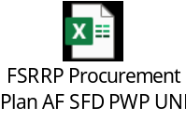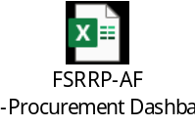

Budget Status
The table below shows expenditure during the reporting period, July 1-Dec 31 2025, and the cumulative expenditure.
Table 7: Budget Status/IP/AF
IP | Description | Grant Allocation | Delivery
IP | Description | Grant Allocation | Total expenditure  (01 Jul – 31 Dec 2025) | Cumulative Expenditure as of 31 Dec 2025 | Overall Burn Rate (%)
SFD | 1) Implementing community-based Cash for Work activities. | 2,820,151.00 | 6,204.76 | 1,678,640.44 | 60%
SFD | 2) Implementing community Contracting Sub-projects. | 16,307,832.00 | 1,151,371.88 | 12,114,761.12 | 76%
SFD | 3) Supervising implementation, conducting, trainings. | 1,716,614.00 | 75,251.83 | 1,257,274.70 | 77%
SFD | 4)Shared Cost between Sub-projects/Activities. | 1,226,153.00 | 111,043.05 | 1,057,120.42 | 88%
SFD | 5) SFD's Operating expenses | 2,452,306.00 | 368,824.00 | 1,775,086.01 | 72%
SFD | SFD TOTAL | 24,523,056.00 | 1,712,695.52 | 17,882,882.69 | 74%
PWP | Activity 1: Implementing community based civil works for the rehabilitation of community infrastructure | 8,505,697.00 | 1,215,650.66 | 4,573,899.85 | 54%
PWP | Activity2: Conducting consultancy and monitoring services to support the implementation | 1,063,228.00 | 106,640.48 | 544,253.68 | 51%
PWP | Activity3: Operating Expenses | 1,063,228.00 | 203,958.15 | 660,013.71 | 62%
PWP | PWP TOTAL | 10,632,153.00 | 1,526,249.29 | 5,778,167.24 | 54%
UNDP | UNDP Direct Operating Cost | 3,130,505.29 | 416,039.50 | 2,227,980.20 | 71%
UNDP | UNDP GMS 5% | 1,914,285.71 | 181,832.10 | 1,293,534.42 | 68%
UNDP | UNDP Total | 5,044,791.00 | 597,871.77 | 3,521,514.79 | 70%
TOTAL |  | 40,200,000.00 | 3,836,816.41 | 27,182,564.55 | 70%

IMPLEMENTATION OF ENVIRONMENTAL AND SOCIAL FRAMEWORK

Environmental and Social Framework (ESF) Status
All Environmental and Social Frameworks (ESF), including the Environmental and Social Commitment Plan, Labor Management Procedure, Gender and GBV Plan, and Security Management Plan for both the parent fund and the additional financing, were cleared by the WB by 16 July 2023. The updated ESF tools have been published and disclosed on the UNDP and Implementing Partners' websites.
Additionally, UNDP updated the fifth draft of the Stakeholder Engagement Plan (SEP), incorporating data collected from January to December 2024. This draft was shared with the Food and Agriculture Organization (FAO) to gather updates from other involved UN agencies. The finalized SEP was cleared by the WB team in August 2025.

Environmental and Social Plans and Risk Assessments
Since the start of the FSRRP AF through December 2025, a total of 30 Environmental and Social Action Plans (ESAPs), 12 from the Social Fund for Development (SFD) and 18 from the Public Works Project (PWP), have been developed for YFSRRP activities and submitted to the World Bank. These ESAPs cover 102 sub-projects with a combined cost of $15,332,912. All ESAPs have been reviewed and approved by the WB.

In addition, 30 Environmental and Social Risk Assessment and Clauses (ESRAACs), 22 from SFD and 8 from PWP, were developed for the YFSRRP activities and submitted to UNDP, covering 62 sub-projects with a combined cost of $12,270,916. UNDP has approved/cleared all the ESRAACs and submitted a copy to the WB. For more details, please refer to Annex 1 ‘Detailed Environmental and Social Risk Management Report”.

Table 8: Status of ESAP and ESRAAC developed during the reporting period.
IP | Number of ESAPs/ESRAACs | Number of Sub- Project | Cost of sub-project | Cleared Plans
SFD | 34 | 99 | $ 19,526,288 | 34 ($ 19,526,288)
PWP | 26 | 65 | $ 8,077,540 | 21 ($ 8,077,540)
Total | 60 | 164 | $ 27,603,828 | 60 ($ 27,603,828)

Table9: Developed plans per category
 | ESAP | ESRAAC
Plan per category | 30 | 30
Projects | 102 | 62
Cost USD | $ 15,332,912 | $ 12,207,916

Conflict Sensitivity
UNDP ensures IPs adherence to no conflict and “DO NO HARM” approaches in their activities, thus ensuring any related issues are flagged and responded to in a timely manner. During the reporting period, no conflict case has been recorded from the IPs. No conflict related case was recorded through the UNDP toll free number.

Environmental and Social Safeguard Monitoring Indicators
The table below demonstrate the progress on the environmental and social monitoring indicators during the reporting period.
Table 10: Safeguard Monitoring Indicators
Area of safeguard indicator | SFD | PWP | TOTAL
Numbers of work Permits issued | 770 | 440 | 1,210
Numbers of OHS and Emergency plan awareness taken place | 1,211 | 148 | 1,359
Number of GM awareness sessions were taken place | 1,211 | 148 | 1,359
Number of awareness sessions on CoC for workers were held | 1,148 | 1,032 | 2,180
Number of gender and GBV awareness sessions provided to community members | 1,211 | 148 | 1,359
Numbers of field visits conducted in the reporting period | 22 | 78 | 100
Number of the Community committee reports submitted to IPs | - | - | -
Number of workers under than 18 years | - | - | -
Numbers of incidents happened during the work | - | - | -

Incidents and Accidents
During the reporting period, no accidents or incidents were reported by either SFD or PWP across the sub-project sites. This reflects the continued strengthening of occupational health and safety practices, as well as improved awareness and compliance with safeguard requirements among contractors and workers. UNDP has reviewed and verified the information submitted by the Implementing Partners (IPs), confirming that no minor, serious, or fatal incidents occurred during this period.
Table 11: Summary of incidents/IP
IP | Sub-projects number | Working-Hours (2025) | Working-Hours (Cumulative) | No of Accidents (bi-annual) | Cumulative No of Accidents | Percentage of Accidents per W.H
SFD | 73 | 1,545,564 | 7,218,961 | 0 | 19 | 0
PWP | 34 | 3,268,085 | 4,414,989 | 0 | 11 | 0
Cumulatively, a total of 30 accidents have been reported across sub-project sites, with 19 incidents recorded at SFD sites and 11 at PWP sites. These included 26 minor incidents, three moderate incidents, and one near miss. The majority of these incidents were attributed to lapses in adherence to the health and safety measures outlined in the Environmental and Social Frameworks and site-specific Occupational Health and Safety (OHS) instructions. While the incidents did not result in significant harm, UNDP has emphasized the importance of strict compliance with OHS protocols. Implementing partners and contractors have been reminded to ensure safe working positions, proper handling of equipment and tools, and ongoing supervision of site activities.
No critical case of fatality, lost time injury, acts of violence or child labor was reported during the reporting period. No cases of Gender-Based Violence (GBV), Sexual Exploitation and Abuse (SEA), or security-related incidents were reported from any of the sub-project sites during the reporting period.

Capacity Building Trainings and Awareness
The capacity building activity aims to equip the relevant staff of IPs with the necessary knowledge, skills, and resources to effectively mainstream gender throughout the project life cycle and successfully implement strategies and actions to prevent Gender-Based Violence and Sexual Exploitation and Abuse. It also seeks to enhance institutional capacities to increase the participation of women in cash-for-work interventions by designing women-friendly activities, raising awareness about challenges hindering women's participation, discussing suitable solutions to bridge gaps, and strengthening partnerships and coordination with relevant agencies. Additionally, the activity aims to document and replicate success stories and best practices.
The cumulative status of safeguard capacity building provided by SFD and PWP for different target groups is presented in the following tables:
Table 12: Environmental and Social Risk Management Awareness
Awareness | SFD |  |  |  | PWP
Awareness | OHS, Gender & GBV |  | GM |  | Environmental, Social, CoC, OHS, and GM
Awareness | Male | Female | Male | Female | Male | Female
Consultant Engineer | 38 | 0 | 14 | 0 | 24 | -
Resident Engineer | 88 | 0 | 13 | 9 | 48 | -
Contractors | 146 | 5 | 0 | 0 | 6 | -
Workers | 1,623 | 30 | 727 | 61 | 958 | 15
Community Committees | 146 | 7 | 52 | 15 | 32 | 11
Local community | 270 | 25 | 276 | 258 | 1,470 | 84
Total | 2,311 | 67 | 1,082 | 343 | 2,538 | 110
Table 13: Environmental and Social Risk Management Training
IP | Topic | Date | Location | Participants
 |  |  |  | Male | Female
PWP | Environment, Social Safeguard, and OHS | Jul. 25 | Taiz | 132 | -
PWP | Environment, Social Safeguard, and OHS | Sep. 25 | Ibb | 80 | -
PWP | Environment, Social Safeguard, and OHS | Sep. 25 | HQ | 42 | -
SFD | Gender, OHS, Social, Environment | Jul. 25 | Ibb | 19 | -
SFD | Gender, OHS, Social, Environment | Jul. 25 | HQ | 85 | 51
SFD | Gender, OHS, Social, Environment | Jul. 25 | Aden | 18 | 12
SFD | Gender, OHS, Social, Environment | Jul. 25 | Hajjah | 45 | 4
SFD | Gender, OHS, Social, Environment | Oct. 25 | HQ | 14 | 6
 |  |  |  | 230 | 79
Total |  |  |  | 665 | 152

Field Visits
During the second half of 2025, a total of 103 field visits were conducted to monitor compliance with safeguard instruments at sub-project locations during the implementation of sub-project activities. Of these, 3 visits were conducted by the UNDP team, 22 by the SFD team, and 78 by the PWP team.
The major findings from the site visits were:
- 100 percent of visited sub-projects have ESMP on site.
- 100 percent of visited sub-projects have emergency plans posted in visible places.
- 100 percent of visited sub-projects show availability of First Aid Kits (FAK).
- 100 percent of visited sub-projects show GM posters.
- 98 percent of visited sub-projects show availability of complaints boxes.

For the sub-projects where the social safeguard and environmental requirements were not fully met, the IPs staff, consultants and the contractors were briefed about the importance of 100 percent compliance and instructed them to avail the missing equipment and information at each sub-project location.

Gender Mainstreaming
UNDP and implementing partners took concrete steps to ensure gender inclusion was mainstreamed across all stages of the project, promoting equitable opportunities for women and persons with disabilities. These efforts included engaging qualified women in technical and social roles such as female consultants leading social assessments and community awareness activities enhancing women’s representation on community committees to strengthen local decision-making and monitoring, and expanding safe, culturally appropriate employment opportunities by assigning tasks aligned with local norms (e.g., trainers and supervisors, site cleaning and tree planting, and concrete curing). UNDP held on 13 August a strategic workshop defined culturally and physically appropriate cash for work options for women and persons with disabilities to broaden dignified livelihood opportunities to discuss and validate a set of activities under the cash for work component that are socially acceptable and physically appropriate for both women and persons with disabilities (PWDs). These activities aim to expand the range of economic opportunities available at the field level, representing a key step toward increasing women’s participation and promoting inclusive economic engagement.

An updated SEAH prevention and mitigation plan has been developed in line with the revised template, reinforcing safeguard measures and ensuring full compliance with PSEA/PSEAH accountability standards, reporting and referral procedures, and the established SEAH reporting pathway. In parallel, capacity-building efforts are being advanced through the preparation of terms of reference for online SEA/SH case investigation training for staff of the three implementing partners. This training is designed to strengthen investigators’ competencies in conducting professional, confidential, and survivor-centered SEA/SH investigations
Social Fund for Development: During the reporting period, SFD intensified awareness-raising and capacity-building efforts related to the Code of Conduct, Gender, GBV, Occupational Health and Safety (OHS), and the Grievance Mechanism (GM), with a strong focus on SEA/SH prevention and mitigation. These awareness sessions were conducted reaching a wide range of stakeholders, including consultants and resident engineers, contractors, workers, community committee members, and local community representatives. Overall outreach under OHS, Gender, and GBV awareness activities reached 2,378 participants (2,311 men and 67 women), while GM-related awareness activities reached 1,425 participants (1,082 men and 343 women). Engagement was particularly strong among workers and community committees, reflecting SFD’s emphasis on frontline implementation and community-level accountability. SFD also conducted internal trainings on Gender, OHS, and environmental and social safeguards in July and October 2025 across headquarters and field offices (Ibb, Aden, and Hajjah), reaching a total of 230 staff, including 79 women, thereby strengthening institutional capacity and safeguards compliance.
Public Works Project: During the reporting period, PWP carried out awareness-raising activities on environmental and social safeguards, the Code of Conduct (CoC), Occupational Health and Safety (OHS), and the Grievance Mechanism (GM), reaching a total of 2,648 participants, including 110 women. While overall participation remained male-dominated due to the construction-focused nature of the activities, targeted outreach facilitated women’s engagement, particularly within the local community (84 women) and community committees (11 women). These efforts enhanced women’s understanding of safeguard standards and informed them about appropriate actions and reporting mechanisms in case of exposure to any form of misconduct, including GBV or SEA/SH.

Grievance Mechanism (GM)
During the second biannual period of 2025, a total of 205 complaints were recorded. Of these, 108 complaints were related to SFD sub-projects, of which 93 were credible. Among the complaints for SFD sub-projects, 98 percent (106 out of 108) were submitted by males, and 2 percent (2 out of 108) by females. Nearly 75 percent related to disputes over financial dues, followed by 13 percent of the reported complaints were associated with Technical.
For PWP sub-projects, 97 complaints were recorded during the reporting period. All complaints were submitted by males. The majority of the complaints (50 percent) were related to disputes over financial dues.
Of the 205 complaints recorded, 92 percent (189 out of 205) were resolved and closed, while 8 percent (16 out of 205) remain pending. Among the resolved complaints, 90 percent were addressed within 14 days, excluding those related to financial issues which took longer to gather additional information, time and resources to address. PWP are currently conducting a verification process for the remaining 16 pending complaints, which are expected to be resolved shortly. For more details, please refer to Annex 1 'Detailed Environmental and Social Risk Management Report. The table (8) below provides a summary of the complaints categorized by their nature.
Table 14: Received complaints during the reporting period by category
Contractual | ES/OHS | Financial | General | Inclusion in the Selection | Technical | Administrative | Labor and Working Conditions
17 | 13 | 130 | 15 | 6 | 17 | 5 | 2
8% | 6% | 64% | 7% | 3% | 8% | 3% | 1%

Stakeholder Engagement & Consultations
The implementing partners conducted 5 public consultations with 313 participants, among which 189 were male (60 percent) and 124 were female (40 percent). The consultations focused on the project activities to raise awareness about the social and environmental compliance during the design and implementation. Most importantly, the consultations highlighted the community's engagement in the selection of project activities based on community needs.
As part of the engagement process, 5 new community committees have been established, with 31 males (75 percent) and 10 females (25 percent). These nominated community committees have played a strategic role in the community's needs assessments and decision-making about the selection and implementation of project activities. For more details, please refer to Annex 1 'Detailed Environmental and Social Risk Management Report.

MONITORING AND EVALUATION

UNDP Field Visits
By December 2025, the UNDP Project Management Team (PMT) conducted a total of 51 field visits to sub-project sites across seven governorates, including six new visits during the reporting period in Lahj (Tuban) and Tur Al-Baha districts.
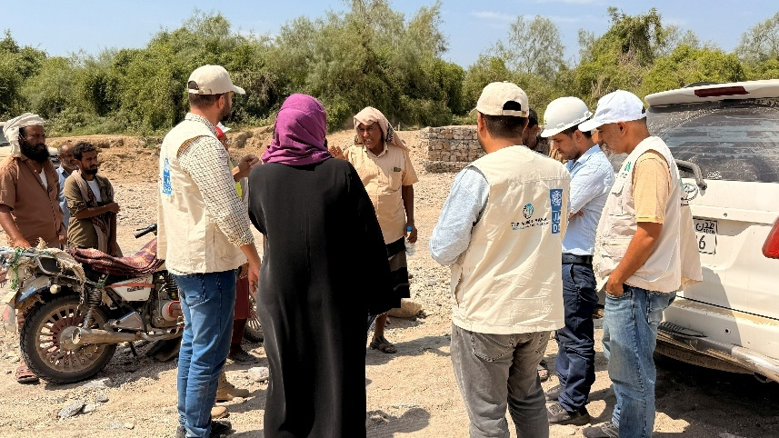
These missions were conducted jointly by UNDP- PMT and implementing partners (IPs)—the Social Fund for Development (SFD) and the Public Works Project (PWP)—primarily in response to severe flash floods affecting the targeted areas. The objectives were to assess flood impacts on ongoing and completed interventions, evaluate implementation progress, and examine the structural integrity, quality, and sustainability of infrastructure under post-flood conditions. The missions also reviewed compliance with approved technical specifications and environmental and social safeguards, as well as the level of community engagement. A mixed-methods approach was applied, combining direct site observations, key informant interviews, asset verification, and a review of project documentation.
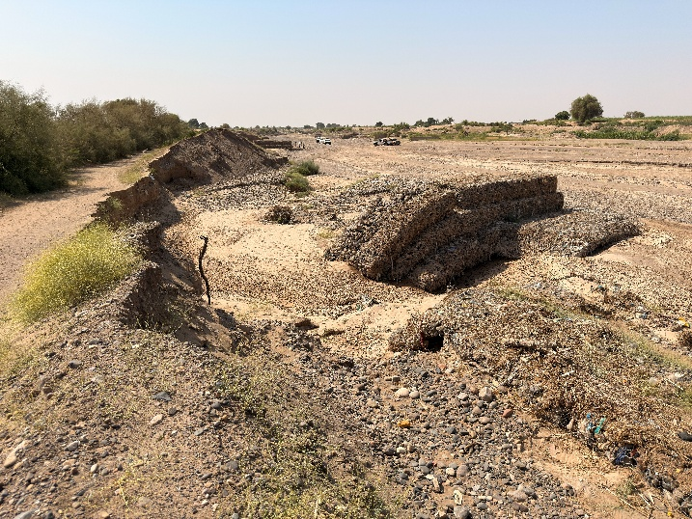
In Lahj–Tuban, rehabilitation and protection work targeting key irrigation canals—Abr Al-Mansouri, Abr Jadeed Al-Azbiya, and Abr Jadeed Al-Majhafa—were implemented by PWP, alongside SFD interventions in Al-Majhafa and neighboring villages. Local stakeholders reported that the October 2025 flash floods were unprecedented, exceeding the magnitude of floods recorded in 1982 and significantly altering the valley’s landscape.
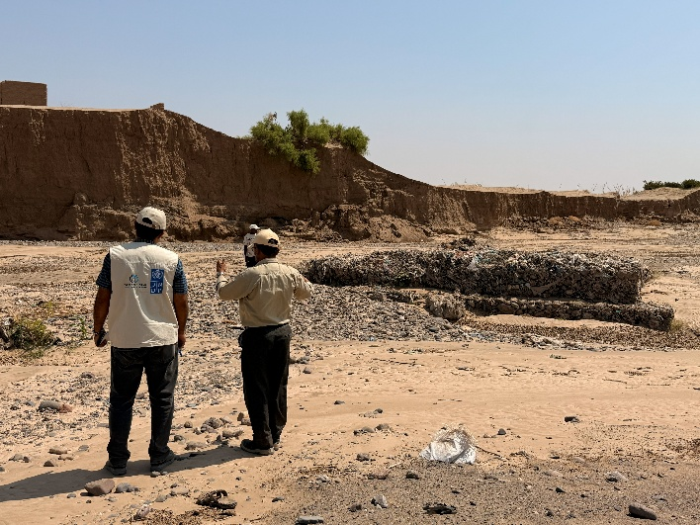
As a result, several protection structures implemented by both SFD and PWP sustained partial damage, leading to extensive farmland erosion. SFD site staff recommended reassessing wadi alignments and intervention priorities to ensure future investments are aligned with the post-flood context and reduce vulnerability to similar events. In response, UNDP included these sites in the TPM Quality Assurance (QA) scope in Q4 2025 to enable a detailed technical damage assessment.
The PWP-implemented sub-projects successfully constructed protection walls benefiting approximately 120 hectares of farmland and 6.3 km of irrigation canals, directly improving the livelihoods of 135 farmers. In contrast, the SFD sub-project remains in its early implementation stage and has been suspended due to internal governance challenges, with completed works further damaged by the floods.
Lahj – Tur Al-Baha District
In Tur Al-Baha, interventions focused on constructing agricultural protection walls and rehabilitating canal entrances in Wadi Al-Shu’bah, under a geographically bundled approach implemented jointly by PWP and SFD. These interventions aim to protect irrigation systems, mitigate erosion risks, and preserve agricultural productivity across a wider area.
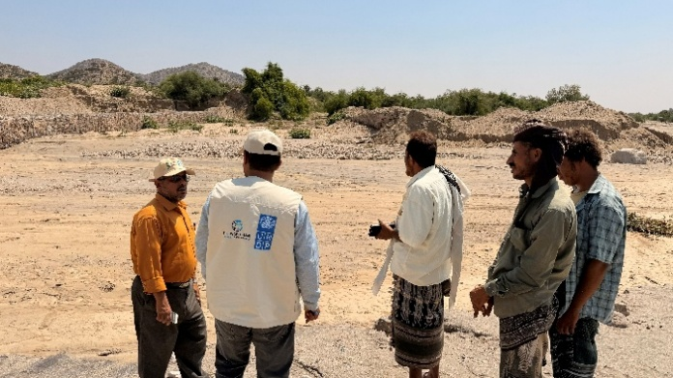
The SFD sub-project in Al-Shu’bah Al-Sofla was observed to be 73 percent complete but remains suspended due to governance issues. Once completed, it is expected to protect approximately 120 hectares of farmland and rehabilitate 3 km of irrigation canals. Field observations identified vulnerabilities behind one stone protection wall where floodwater continues to pass through, posing risks to canal entrances. This issue—previously reported during the May 2025 mission but not addressed due to the suspension—was attributed to flooding during construction and highlights the need for additional protective measures, such as secondary walls or gabions.
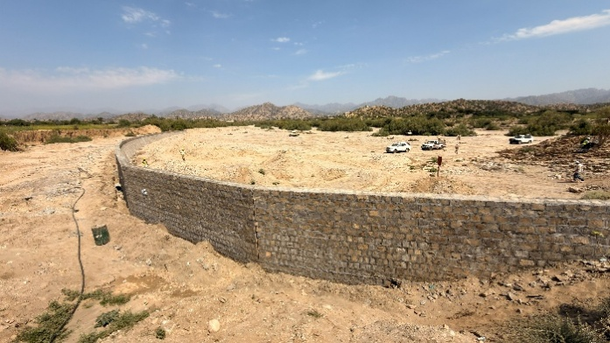
The PWP sub-project in Tur Al-Baha demonstrated steady progress, reaching 57 percent completion at the time of the visit. The intervention benefits approximately 63 hectares of farmland and generates 290 short-term employment opportunities through wage labor. Strong community engagement was evident throughout the project cycle, with community committees actively involved in planning, monitoring, and implementation. Contractors and wage workers were primarily selected from local communities through transparent and equitable processes, prioritizing vulnerable households, while skilled labor was sourced from nearby areas when unavailable locally.
Recommendation:
To enhance resilience and reduce future flood risks, detailed site-specific technical assessments should be conducted by IPs to identify vulnerable sections, reassess wadi alignments, and realign intervention priorities in light of post-flood conditions. FSRRP Field Mission Report

Third-Party Monitoring (TPM)
Following the suspension of the initial TPM provider by DFA authorities in March 2024, UNDP—working jointly with the World Bank—established a revised monitoring arrangement. This approach relies on specialized external firms, including an engineering consultant for technical quality assurance and a separate audit firm for targeted financial spot checks.
Engineering Quality Assurance and Verification
During the reporting period, the engineering firm conducted quality assurance assessments for 31 sub-projects implemented by SFD and PWP. Overall findings indicate a high level of technical and environmental compliance, despite challenges related to external factors such as banking disruptions and labor availability. Lessons from these assessments are informing adaptive implementation and sustainability planning.
SFD-Implemented Sub-Projects
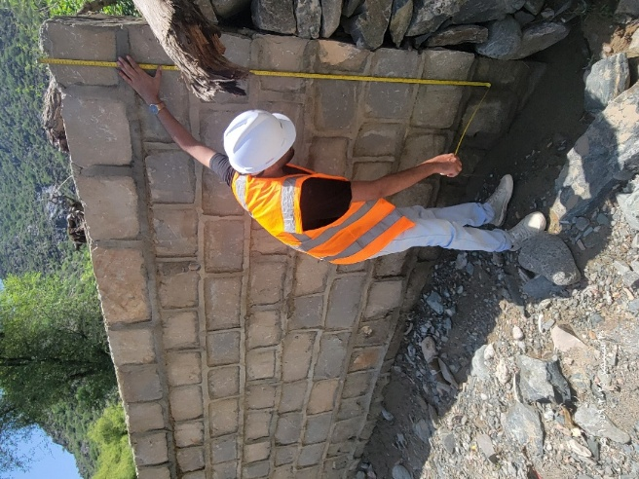
Across 23 sub-projects in 16 districts, all assessed assets were fully operational and effectively serving their intended purposes. Infrastructure demonstrated strong resilience to seasonal rainfall, with no structural failures attributable to design or material deficiencies. Minor damages observed were linked to unauthorized community modifications beyond original design assumptions. Overall quality was rated satisfactory for 96 percent of sub-projects, with 91 percent fully compliant with approved designs and Bills of Quantities (BoQs). All QA findings were addressed and formally closed. Climate resilience integration was comprehensive across all sub-projects.
Figure 1 Inspection of Protection Wall Dimensions (Sebah, Abyan 300-14645) by the Engineer during the QA TPM Process
PWP-Implemented Sub-Projects
Eight sub-projects across eight districts also demonstrated sound technical quality and full integration of climate resilience measures. However, progress was affected by funding delays, adverse weather, and localized community challenges. All assessed sub-projects experienced delays ranging from two to five months, although several have since accelerated toward completion. Quality was rated satisfactory in 88 percent of cases, with
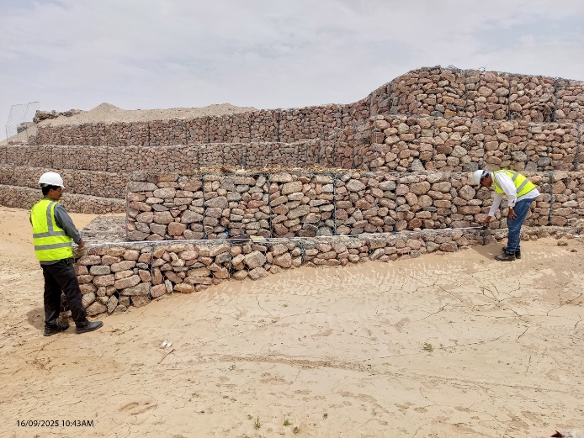
minor non-compliances under active correction. Design deviations were primarily driven by site-specific conditions or beneficiary agreements and remain under close follow-up.
Despite positive technical outcomes, challenges included the sudden suspension of SFD sub-projects, inconsistent documentation formats, and delayed access permits. The Quality Assurance Engineering TPM firm recommended formalizing change-approval mechanisms for community-driven design modifications, accelerating delayed works, standardizing documentation, and sustaining strong emphasis on climate-resilient infrastructure.
Quality Assurance Notices Matrix
All Quality Assurance (QA) findings are systematically recorded in a QA Notices Matrix, supported by documented evidence. Notices are formally communicated to IPs for corrective action and tracked by partner, notice type, status, and sub-project. The QA firm reviews IP responses to determine closure or further follow-up. UNDP provides oversight by validating responses and leading escalation where corrective actions are insufficient. Engineering Quality Assurance Reports (Q3) are available at: [FSRRP Engineering Quality Assurance Reports ]

Financial Spot Checks
An independent audit firm conducted targeted financial spot checks covering the same sub-projects reviewed under the engineering QA exercise. The review verified financial records, alignment with approved workplans and budgets, and compliance with procurement and disbursement procedures, in accordance with ISRS 4400.
The review covered disbursements from 1 April to 30 September 2025 (PWP) and 1 April to 17 August 2025 (SFD). Findings were reported exclusively for PWP, with no reportable issues identified for SFD. Most observations were assessed as low to medium risk, and corrective actions had already been implemented.
Key improvements included the correction of earlier practices related to recording advances for community contracting, now fully aligned with accounting standards and the HACT framework. Contract implementation delays were observed in several sub-projects, driven by funding delays, administrative bottlenecks, currency fluctuations, limited contractor capacity, and material shortages. While justified, these delays highlight the need for stronger contract management and documentation.
Weaknesses in procurement documentation—such as calculation errors and insufficient justification of bid corrections—were also identified but subsequently corrected without affecting procurement outcomes.
Overall, the audit confirmed that issues did not indicate systemic control failures and emphasized the importance of sustaining improvements through ongoing monitoring. Spot Check Verification Reports are available at: [YFSRRP Spot Check Reports ]

Rapid Impact Assessment
Following discussions during the September 2024 Mid-Term Review (MTR) mission, UNDP commissioned a national agricultural economics specialist to assess the financial benefits generated by infrastructure sub-projects. Data were collected from 26 sub-project sites in IRG-controlled areas, covering agricultural land protection, irrigation rehabilitation, water harvesting, and rural roads. The assessment involved 140 household surveys and 30 FGD participants. The draft report was presented during the November 2025 ISM and will be finalized following receipt of World Bank feedback.

MIS Development for Project Management and Geo-Bundling Initiatives
MIS Development for Project Management
All Web Application Penetration Test (WAPT) findings were resolved, and the MIS was fully deployed to production in the second half of 2025. The system now serves as a central data platform for project tracking, reporting, and performance monitoring across WB-funded initiatives. With the MIS now in production, the system is being regularly updated and maintained to support evolving operational needs. It has begun serving as a central data source for project teams, enabling streamlined access to information and supporting decision-making processes across. The successful deployment and operationalization of the MIS in the second half of 2025 represents a major step toward institutionalizing a centralized, transparent, and efficient approach to project management. These efforts position the MIS as a cornerstone for UNDP’s data-driven decision-making and long-term program sustainability.

OTHER ISSUES REQUIRING ATTENTION

Restructuring of activities
There was no restructuring proposed or requested during the reporting period. There is a growing shift toward graduating from CfW to Community contracting (CC), given that most identified sub-projects focus on medium and large infrastructure interventions.
This is in line with the AF Project Appraisal Document PAD and the approved Implementation Mechanism for YFSRRP stating that the mechanism for implementing infrastructure for land and water will primarily be carried out through the CC approach.

Results reporting
As indicated in earlier sections, the RRF was revised in relation to achievements resulting from the reclassification/recategorization of small holder farmers beneficiaries under irrigation canals interventions. This was discussed and endorsed by the WB following the ISM September 2024 and reflected in RRF target revisions.
Achievements were revised based on the above agreement since the start of the project and are reflected in the report. These revisions will be adopted from this report onward.
The final revision is reflected in Section 9: Progress Towards Project Results Framework.

Reallocations between components and/or expenditure categories:
As indicated above, SFD is transitioning from CfW to more community contracting and national competitive bidding. There is no reallocation implied because they are under the same component budget line.

Possible funding gaps: N/A
Component 1 is currently budgeted until December 2025 under the current financing. UNDP is monitoring SDR status as of end-June 2025 for potential exchange rate gains. While these gains are not expected to be significant, they will be used to cover operational gaps for both IPs and UNDP costs. The operational gap was previously highlighted and discussed with the WB, and the agreement was to use any gains to partially cover these costs.
In light of a potential Additional Fund, the funding gap can be bridged. UNDP is currently looking at covering PWP’s operational funding using surpluses under direct implementation, which the TTL confirmed are at the discretion of UNDP.

STATEMENTS ON ALLEGATIONS
UNDP did not receive any allegations of any type and nor did the IPs.

PROGRESS TOWARDS PROJECT RESULTS FRAMEWORK

Progress towards Project Targets
Results chain | Indicators | Baseline | Progress to Dec 31 2025 | Percentage achieved as Dec 31 2025 | End target  (Expected value at project completion)
Intermediate Results Indicators by Components
Improving household incomes through CFW for ag. production infrastructure and climate resilience | Persons benefiting from cash-based transfers (Number) | 0.00 | 42,964 | 81% | 52,900
 | Women recipients benefitting from cash-based transfers (Number) | 0.00 | 3,999 | 57% | 7,000
 | Person work-days generated by emergency Cash for Work schemes (Number) | 0.00 | 1,326,918 | 86% | 1,547,400
 | Person work-days generated by emergency Cash for Work schemes benefiting women (Number) | 0.00 | 130,441 | 68% | 190,700
 | Farmers with improved access to water resources (Number) | 0.00 | 22,341 | 87% | 25,700
 | Female farmers with improved access to water resources (Number) | 0.00 | 5,277 | 88% | 6,000
 | Farmers with improved access to land resources (Number) | 0.00 | 17,249 | 128% | 13,500
 | Female farmers with improved access to land resources (Number) | 0.00 | 4,026 | 149% | 2,700
Project Management and Knowledge Management | Grievances registered and addressed in a timely manner (Percentage) | 0.00

COMMUNICATION
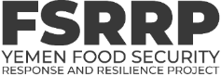
In the second half of 2025, four field documentations were commissioned to capture project progress, document milestones, and produce impact written and video stories. Missions to other locations were rescheduled due to the absence and irregularity of rain falls, which negatively impact farming activities. In addition, FSRRP published two quarterly fact sheets and produced four videos highlighting FSRRPs interventions.
FSRPR Online Media Library:
FSRRP online media library continues to be updated with high-quality photos, video b-rolls, and video soundbites from field documentations to be used for developing stories, videos, publicize FSRRP progress and milestones, and future advocacy and communications. The lates updates captured floods damage in Wadi Tuban, rainwater harvesting tanks in Dhamar, and irrigation intervention beneficiaries in Taiz. Below is FSRRP’s Dropbox online media library outline:
01 Food Security Response and Resilience Project (FSRRP): (main folder)
- 01 FSRRP in the field
  - 01 Agricultural land improvement
  - 02 Irrigation improvement

  - 03 Water harvesting
  - 04 Rural roads improvement
  - 05 FSRRP team missions to the field
- 02 Communication products
  - 01 Videos
  - 02 Written stories
  - 03 Fact sheets
- 03 Visibility products
  - 01 FSRRP Identity package
  - 02 Visibility wearables
  - 03 Roll-up stands
  - 04 WB-UNDP partnership

Communications Coordination meetings with IPs:
Communication coordination meetings with FSRRP implementing partners continue to take place regularly with UNDP leading on documentations missions planning. Through such coordination, FSRRP managed to commission four documentation missions to different governorates in the second half of the year.

Technical Working Group (TWG) with FAO & WFP:
Unfortunately, FSRRP’s technical work group hasn’t held any meetings recently due to the limited capacity in FAO’s Communications- the TWG organizer.
FSRRP Webpage:
FSRRP’s English and Arabic webpages continue to be reviewed and updated as necessary. They now communicate FSRRP’s targets, latest progress and achievements as of December 2025.
Communication Products:
Below is a list of FSRRP’s communication products produced during the second half of the year:
- Written stories/articles:

- Construction of Al-Ghareqah irrigation canal restores life to farmland and farming in Al-Gharegah village:
A draft article on the impact of FSRRP rehabilitation of Al-Gharegah irrigation canal- one of FSRRP’s biggest interventions- restores life to farmlands after years of draught & neglect in Tur Al-Baha, Lahj Governorate.

- Videos stories:
  - World Food Day video (DRAFT):
A promotional video promoting the joint efforts by the World Bank and UNDP to improve Yemen’s food security and climate change resilience through the Food Security and Social Protection projects to be published soon. Below is Dropbox link to the draft video:
  - https://www.dropbox.com/scl/fi/ji0jlwplyve7l11l54j2n/UNDP-YEMEN-2025-OCT-FSRRP-FOOD-DAY-14.10.2025.mp4?rlkey=u4b0moirgyvzlmrqe6vakf9tq&dl=0

  - Better irrigation, better crops- Onion harvest in Al-Makha, Taiz Governorate (DRAFT):
A video capturing the positive impact of improved irrigation on different corps and highlighting onion farmers testimonies in Al-Makha, Taiz governorate. Below is Dropbox link to the draft video:
  - https://www.dropbox.com/scl/fi/630gkcgw8kksfxwb8p31t/20251100-irrigation-intervention-beneficiaries-in-Al-Makha-Taiz-DRAFT-VERSION-NOT-PUBLISHED.mp4?rlkey=sk8pmlyefyqnq9wp05eabfzy1&dl=0
  - Construction of Al Gharegah irrigation canal brings life and farming back to Al Gharegah village (DRAFT):
A video highlighting the benefits and impact of one of FSRRP’s biggest protection and irrigation interventions in Tur Al-Baha district, Lahj Governorate.
  - https://www.dropbox.com/scl/fi/fnfxf63ez76k6seygjte7/UNDP-2025-Oct-FSRRP-Tawr-Al-Baha-Irrigation-Canals-EN-Video-Story.mp4?rlkey=0an5r4rqjy5sojhycsmme2cv6&dl=0

  - Rainwater harvesting tanks in Dhamar governorate- impact video:
A video showcasing a number of FSRRP’s rainwater harvesting tanks and their impact in figures:
  - https://www.dropbox.com/scl/fi/04mqwe1iyzfsbbkgndbzw/FSRRP-Dhamar-water-tanks-AJ-09.11.2025.mp4?rlkey=09ob26x007aiwdp89u09ea8hv&dl=0
- FSRRP’s fact sheets:
In the second half of 2025, FSRRP published Q3 and Q4 infographic fact sheets highlighting FSRPP’s up-
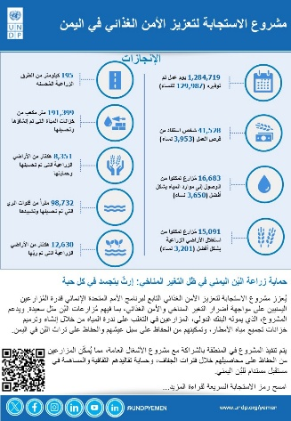
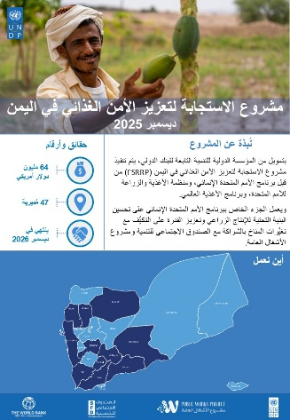
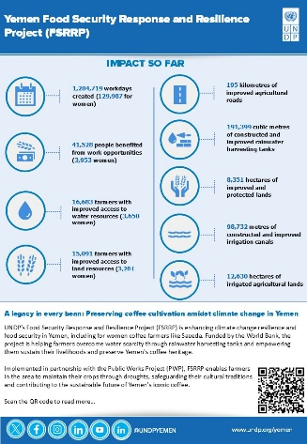
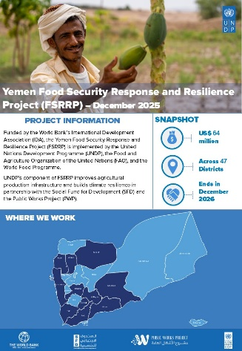
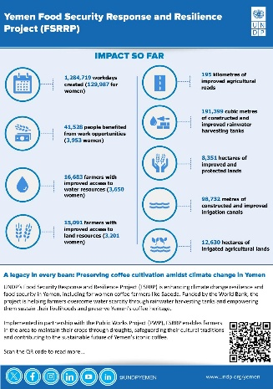
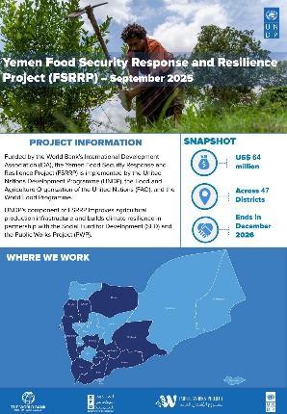
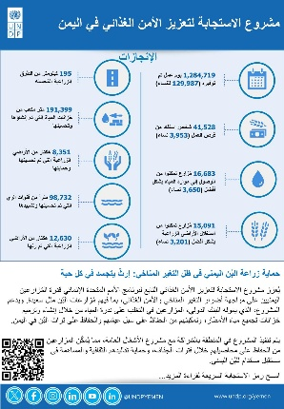
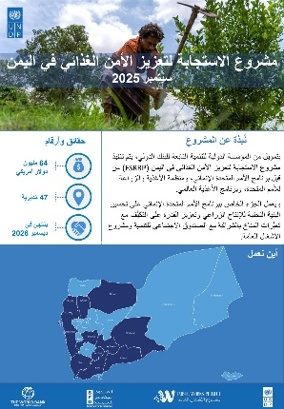
to-date achievements in figures: Below are the fact sheets and links:
FSRRP’s 2025 Q4 fact sheet
FSRRP’s 2025 Q3 fact sheet
Published fact sheets’ links:
- 2025 Q3 FSRRP Fact sheet EN
- 2025 Q3 FSRRP Fact sheet AR
- 2025 Q4 FSRRP Fact sheet EN
- 2025 Q4 FSRRP Fact sheet AR

- Social media:
UNPD, SFD and PWP continue to advocate for and promote FSRRP’s interventions, progress, achievements, and the partnership with the World Bank on their respective platforms with FSRRP’s official hashtag- #FSRRP.

The staffing cost (100 percent for the six national staff and 50 percent for the four international staff).

